BUG LIFECYCLE:

Bug Life Cycle in software testing is the specific set of states that defect or bug goes through in its entire life. The purpose of Defect life cycle is to easily coordinate and communicate current status of defect which changes to various assignees and make the defect fixing process systematic and efficient.

DEFECT STATUS:

Bug Status in defect life cycle is the present state from which the defect or a bug is currently undergoing. The goal of defect status is to precisely convey the current state or progress of a defect or bug in order to better track and understand the actual progress of the defect life cycle.

BUG:

The Bug is the informal name of defects, which means that software or application is not working as per the requirement.

In [software testing](https://www.javatpoint.com/software-testing-tutorial), a software bug can also be issue, error, fault, or failure. The bug occurred when developers made any mistake or error while developing the product.

DEFECT:

A defect in software testing refers to any flaw or error in the application that restricts the normal flow of an application by mismatching the expected behavior of an application with the actual one.1 Defects can also be defined as any deviation or irregularity from the specifications mentioned in the product functional specification document.

FAULT:

An incorrect step, process or data definition in a computer program that causes the program to perform in an unintended or unanticipated manner. A fault is introduced into the software as the result of an error. It is an anomaly in the software that may cause it to behave incorrectly, and not according to its specification. It is the result of the error.

The software industry can still not agree on the definitions for all the above. In essence, if you use the term to mean one specific thing, it may not be understood to be that thing by your audience.

FAILURE:

A failure is the inability of a software system or component to perform its required functions within specified performance requirements. When a defect reaches the end customer it is called a Failure. During development, Failures are usually observed by testers.

ERROR:

An error is a mistake, misconception, or misunderstanding on the part of a software developer. In the category of the developer, we include software engineers, programmers, analysts, and testers. For example, a developer may misunderstand a de-sign notation, or a programmer might type a variable name incorrectly – leads to an Error. It is the one that is generated because of the wrong login, loop or syntax. The error normally arises in software; it leads to a change in the functionality of the program.

CASE 1(ACCEPTANCE):

* ****New:**** When a new defect is logged and posted for the first time. It is assigned a status as NEW.
* ****Assigned:**** Once the bug is posted by the tester, the lead of the tester approves the bug and assigns the bug to the developer team
* ****Open****: The developer starts analyzing and works on the defect fix
* ****Fixed****: When a developer makes a necessary code change and verifies the change, he or she can make bug status as “Fixed.”
* ****Pending retest****: Once the defect is fixed the developer gives a particular code for retesting the code to the tester. Since the software testing remains pending from the testers end, the status assigned is “pending retest.”
* ****Retest****: Tester does the retesting of the code at this stage to check whether the defect is fixed by the developer or not and changes the status to “Re-test”.
* ****Verified****: The tester re-tests the bug after it got fixed by the developer. If there is no bug detected in the software, then the bug is fixed and the status assigned is “verified.”

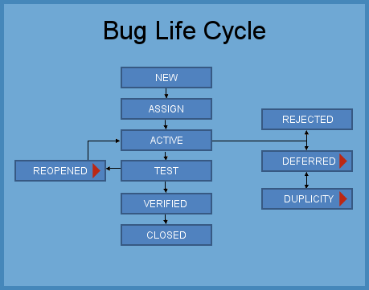

CASE 2(NOT ACCEPT):

* ****Reopen****: If the bug persists even after the developer has fixed the bug, the tester changes the status to “reopened”. Once again the bug goes through the life cycle.
* ****Duplicate****: If the defect is repeated twice or the defect corresponds to the same concept of the bug, the status is changed to “duplicate.”
* ****Rejected****: If the developer feels the defect is not a genuine defect then it changes the defect to “rejected.”
* ****Deferred****: If the present bug is not of a prime priority and if it is expected to get fixed in the next release, then status “Deferred” is assigned to such bugs
* ****Not a bug****: If it does not affect the functionality of the application then the status assigned to a bug is “Not a bug”.
* ****Closed****: If the bug is no longer exists then tester assigns the status “Closed.”